Scenario:

1. Enter transaction code VX11.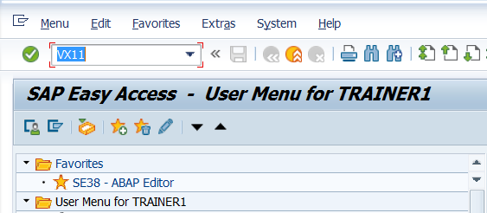
2. Enter the details as shown below and press enter.  
   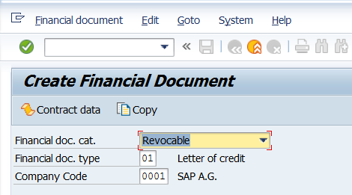
3. Observe the screen below.

Steps for Screen Exit.

1. On the above screen, check System Status

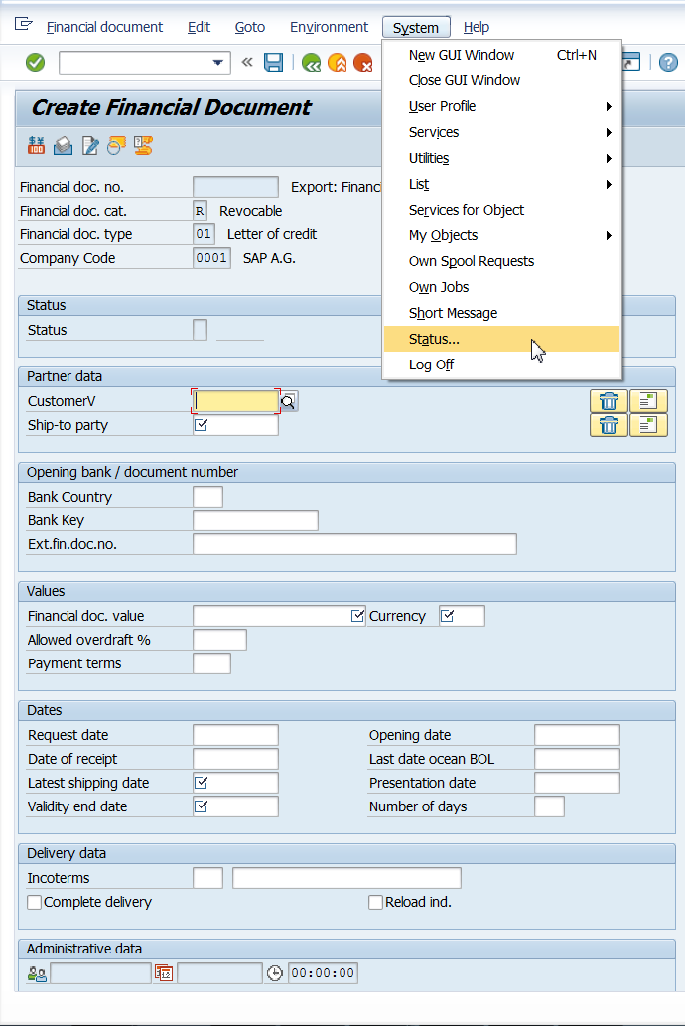

1. Double click on the program name SAPMV86E and it takes us to the corresponding program in SE38.

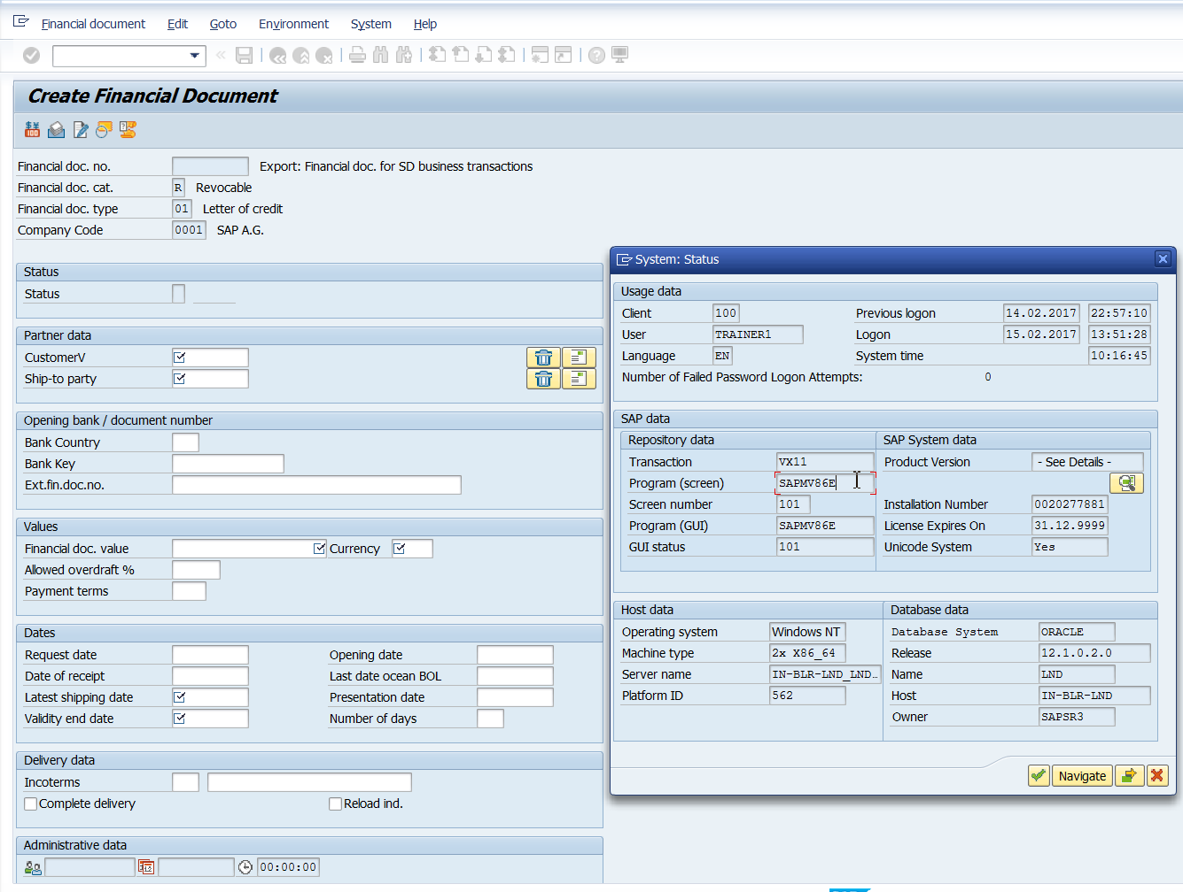

1. Check the attributes of the program. Go to Attributes in the Menu. Observe the package name.

Steps 1 to 3 can be skipped by just going to Tcode SE93 and entering the Tcode VX11 and u can directly get the package name.

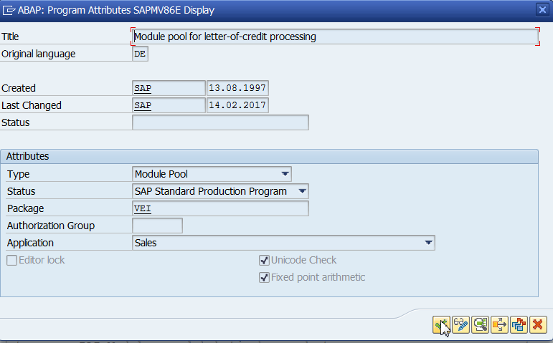

1. Go to SMOD.

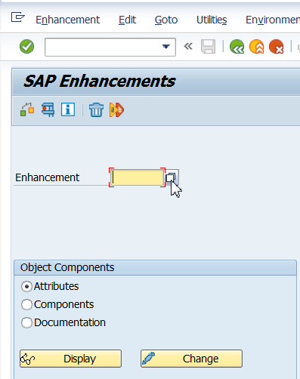

1. Click on the box (F4) of Enhancement field. Click on Information System.

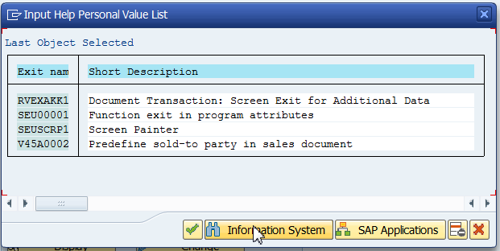

1. Enter package name and click continue.

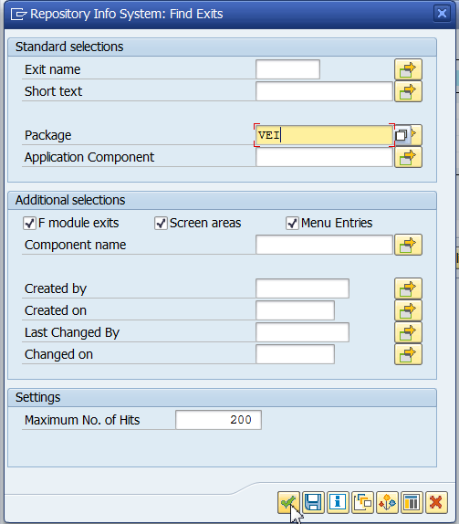

1. Observe the exits.

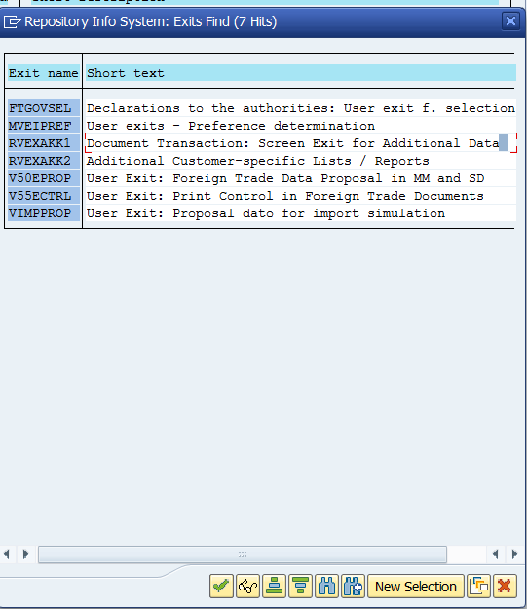

1. RVEXAKK1 is the exit we need to modify.
2. Go to CMOD

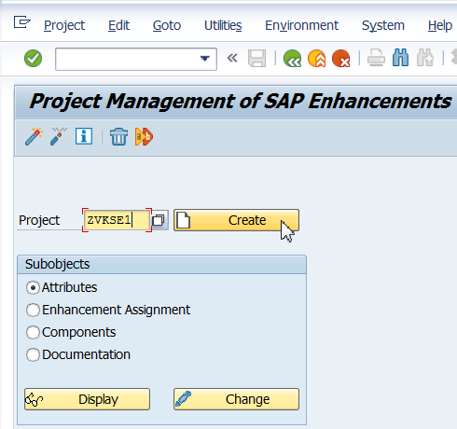

1. Click on Enhancement assignments.

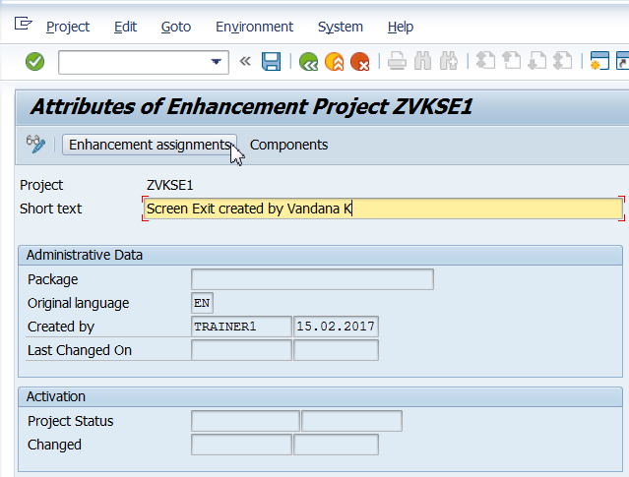

1. Save it in a package or as a local object.
2. Enter the enhancement name as shown below and press enter. The text is automatically displayed. Click on components.

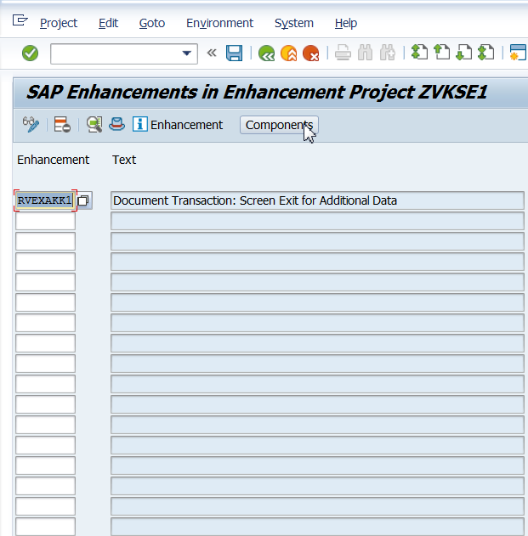

If it throws you an error saying the exit is already assigned to a project.

Go to that project deactivate it and try again. If the error persists, then u may have to delete that project.

1. Double Click on the selected exit.

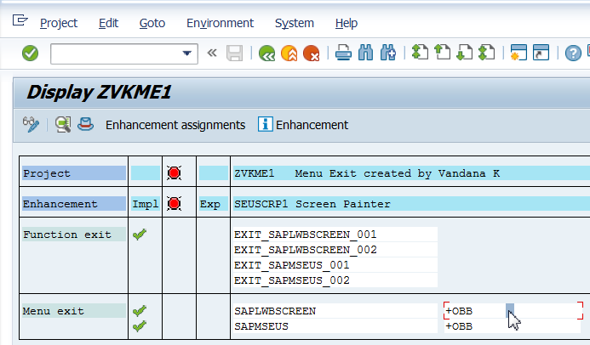

It will show above screen or below screen if screens are already created previously

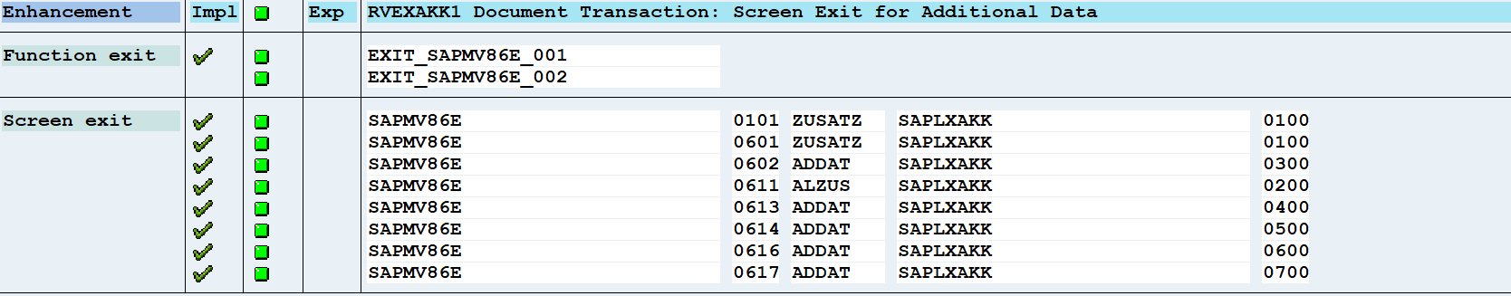

Click on the 0101 that appears against SAP MV86E – in short, we are opening a screen, delete whatever is in the layout of the screen and then create your own fields using any table, which you want to add to the screen of VX11 Tcode.

1. Enter Function Text as shown below.

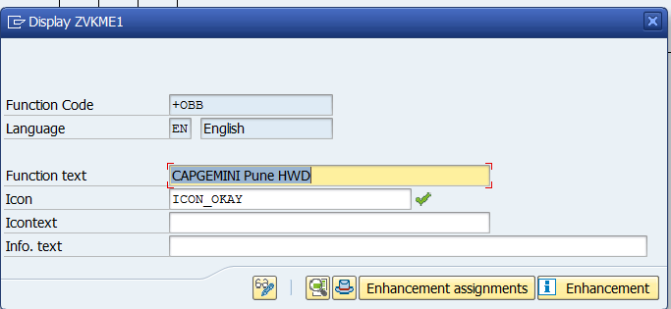

1. Click on Change.

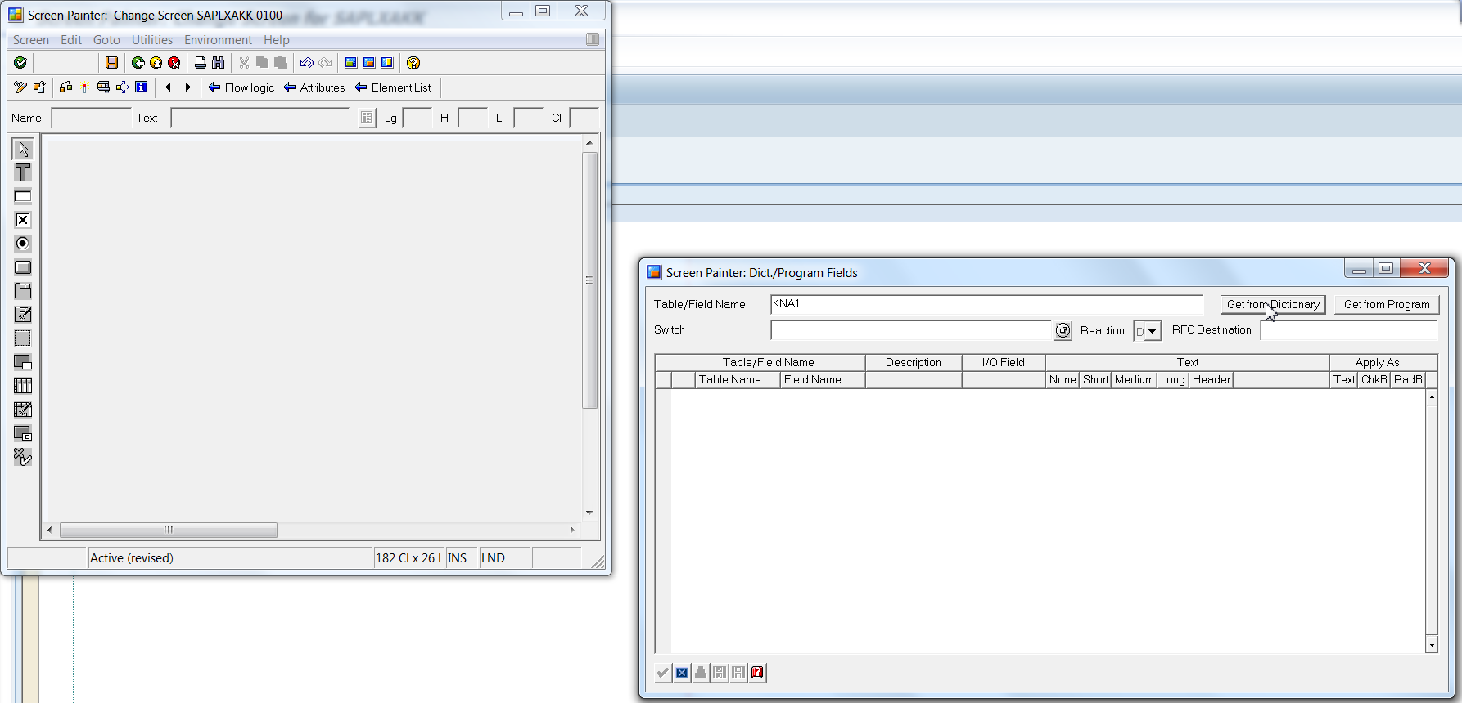

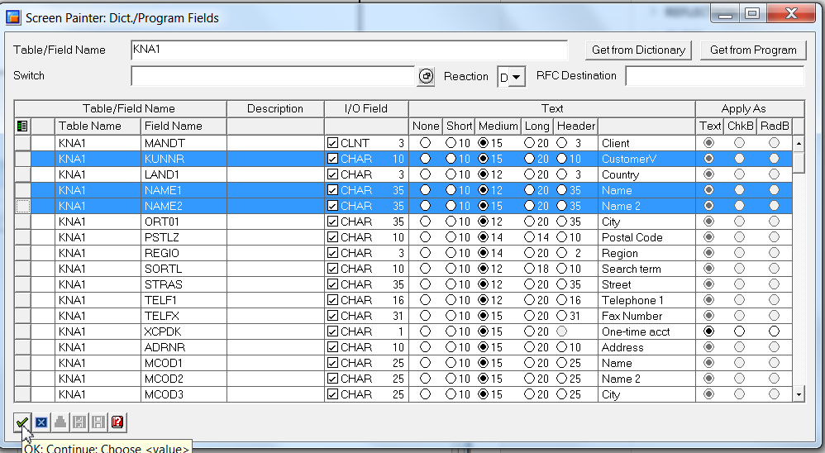

1. Save and activate.

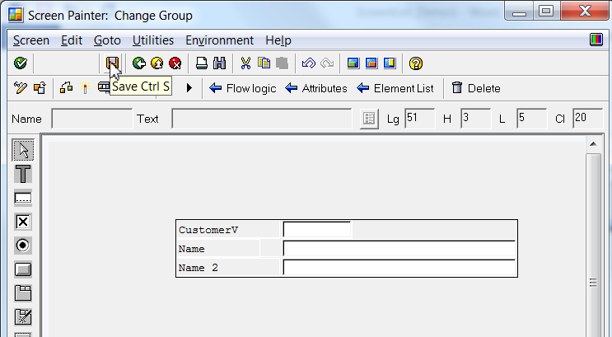

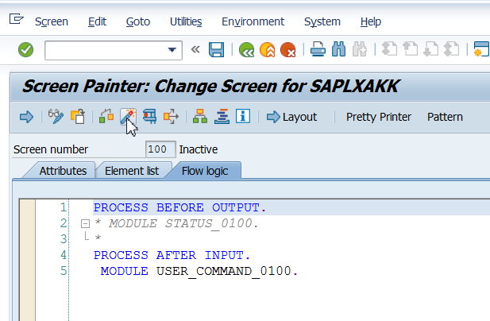

1. Save. Activate. Press F3. Till you reach the below screen and ensure that the exit is activated.

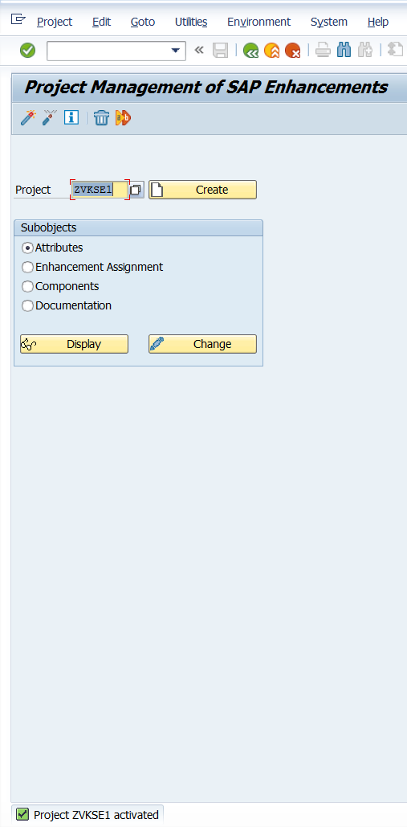

1. Go to VVX11 and enter details as shown below and press enter.

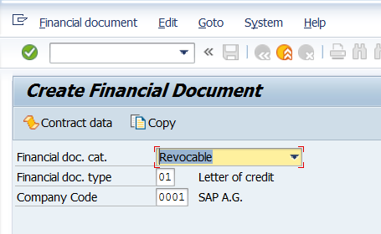

1. Scroll down and observe additional data.

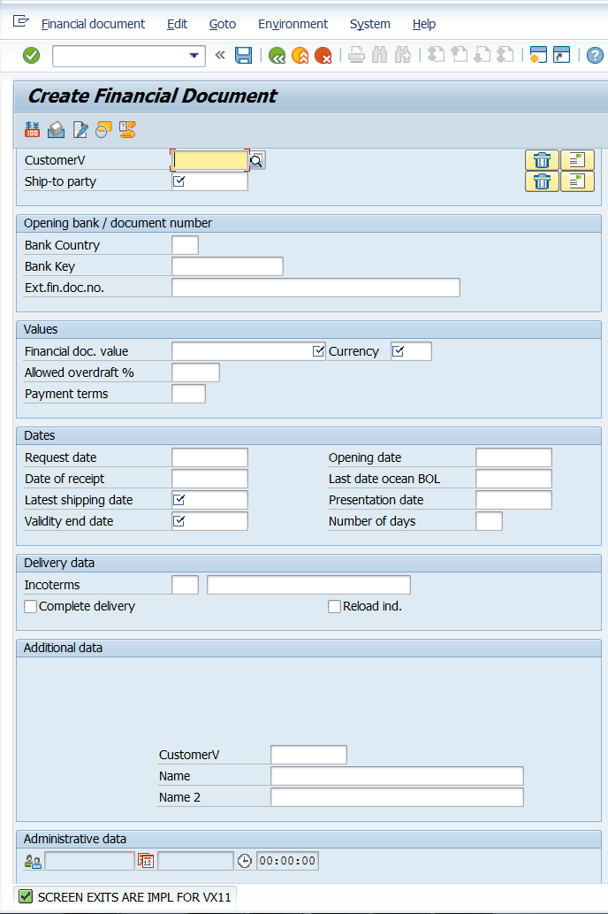

If the screen exit is deactivated, the additional data is not visible.

Please ensure to delete your project after you are done practicing.